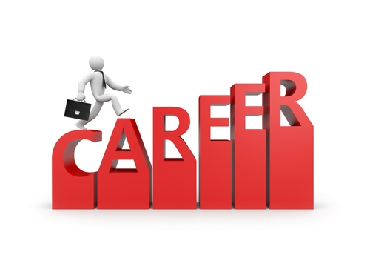
Employers consider that employment related skills are just as important as job-specific or technical skills. You gain a variety of employment related skills in every subject you study at school. Therefore, it is important to record all the skills you develop so you can prepare a résumé and be better prepared to select courses and careers in the future.

Below is a list of employment related skills which students at The Entrance Campus develop and demonstrate throughout their senior studies.

- Self-management – Ability to take the responsibility for setting and achieving personal goals

- Initiative and enterprise – Ability to seek/take advantage of opportunities

- Learning – Ability to achieve new skills and/or knowledge

- Communication – Ability to express and understand information

- Teamwork – Ability to work effectively with others to get things done

- Planning and organising – Ability to coordinate and prioritise tasks and resources

- Problem solving – Ability to identify problems and develop solutions

- Technology – Ability to use appropriate technologies to complete tasks

- Cross-cultural understanding – Ability to respect diversity and act without discrimination

